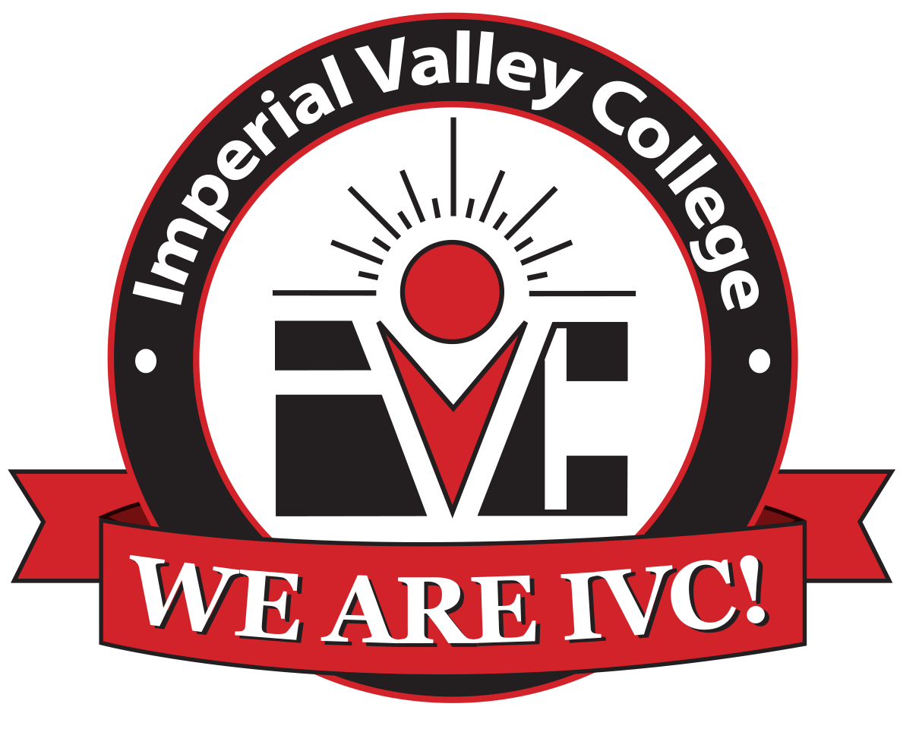

Program Review Committee (PRC)

PRC
Program Review Handbook
Academic, Student, and Administrative Areas
Developed by: Offices of Institutional Effectiveness and Research
Draft: 10_22_21

Introduction
We are excited to present to you the 2021-2022 Program Review Handbook! The handbook will contain important information regarding the program review process. This year, we successfully launched the Nuventive platform and began the process of integration of campus-wide program reviews and assessments. The Offices of Institutional Effectiveness and Research are ready to support your program review and data needs.

Background:
Program Review has been part of the Imperial Valley College culture for over two decades. The purpose of program review is to examine programs/units for institutional effectiveness, integrated planning, viability, and relevancy to the College Mission, Vision and Values, any current plans or initiatives (Vision for Success, Student Equity, etc) as well as to the IVC 2030 Vision Comprehensive Master Plan.

In Spring 2021, a new governance structure was proposed and two committees were developed. The Institutional Effectiveness and Development Committee (IEDC) and the Program Review Committee (PRC), which would replace the past Strategic Educational Master Planning Committee (SEMPC). PRC is a subcommittee of IEDC and this has increased implementation efforts across the institution. This has ensured that all program review efforts have alignment with accreditation. Significant changes were made in the internal processes and structure for Program Review for both academic and non-academic programs based upon these recommendations that now support and sustain an integrated program review cycle.

It is imperative that institutional program review be fully integrated into all college planning and budgetary processes. To that end, the principles embodied in the original SEMPC document have been adopted as the basis for this official College District model for implementation of institutional program review throughout all units – Academic, Administrative and Student Services.

The PRC has been established to serve as the overall monitor of the program review process. This committee ensures that the relevant information from the various program reviews were routed to the appropriate IVC standing committees for integration into our College’s institutional plans (e.g., program review, outcomes and assessment, budget, and accreditation).

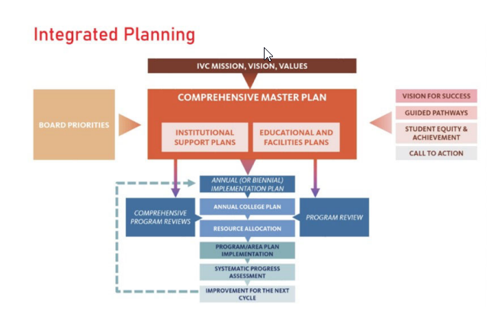

Institutional Goals:

Strategic Goal | Vision for Success Goal | Strategic Goal | Objectives
Strategic Goal A | · Goal 1A  · Goal 2A  · Goal 3A | Provide all students with excellent academic programs and clear pathways to reach the timely completion of their educational goals. | 1. Implement the Completion-by-Design Framework: Correction, Entry, Progress, Completion.  2.Develop a strategic approach to enrollment management and course scheduling.  3. Expand learning opportunities for faculty and staff.  4. Strengthen and expand partnerships (e.g., high schools, four-year institutions, employers).  5. Deliver courses in a variety of modalities (e.g. in-person, online, hybrid.)
Strategic Goal B | · Goal 1A  · Goal 2A | Ensure learning and support the success of all students to meet their education and career goals. | 1.Increase campus collaborations and professional development opportunities focused on improving student success.  2.Improve information technology infrastructure, resources, and training to improve students’ access to programs and support resources.  3. Enhance student support services to increase engagement, persistence, and success.  4.Increase or enhance partnerships with nonprofits and local agencies to address student’s basic needs.
Strategic Goal C | · Goal 4C | Align IVC programs to labor market demands | 1. Redesign existing and/or offer new instructional programs (credit and noncredit) in high-demand, high-wage occupational areas.  2. Expand the work-based learning opportunities (e.g., internships, apprenticeships).  3. Strengthen and expand partnerships – local business and industry.
Strategic Goal D | · Goal 1A  · Goal 5.1A | Strengthen a culture of equity, diversity, inclusion, and social justice. | 1. Increase equitable access to programs and support services at all locations and in all modalities.  2. Increase retention and success rates for all students in all instructional modalities and course types.  3. Develop a human capital management strategy that reflects IVC’s demographic diversity.  4. Provide accurate data and professional development opportunities, which are needed to address inequities and serve disproportionately impacted, underserved students.  5. Implement policies and procedures to regularly audit classroom and campus climates to ensure an inclusive environment.  6. Create regular opportunities for engagement and community-building centered on equity-focused, anti-racist, intersectional lens, and inclusive practices.
Strategic Goal E | · Goal 1A  · Goal 2A  · Goal 3A  · Goal 4C  · Goal 5.1A | Develop and implement responsible and sustainable policies and practices in the allocation and stewardship of all resources to support student access, equity, and success. | 1.Regularly review and renew District policies and practices, which implement principles of fiscal, environmental, physical, technological, and human resources sustainability.  2.Continue to integrate sustainability content across the curricula.  3. Pursue grant opportunities and build collaborative relationships with community, business, and alumni to augment curricular and student support programs.

As part of the CMP, the College has included institutional, educational, and facilities plans that are congruent to that of board priorities and in alignment with the Colelge’s mission, vision, and values. IVC’s Integrated Planning Model is informed by the vision for success, guided pathways, student equity and achievement plan, and the program review plan.

Purpose
The purpose of IVC’s program review process is to review, analyze, and assess the content, currency, direction, and quality of all programs and services in order to invest in the unit’s future.

The intent of the program review process is to promote student-centered services by engaging all college units in self-examination and self-improvement. The review process is to be broad-based, accessible, and integrated into other college-wide processes, such as accreditation, budget, and strategic planning.

The information gathered and analyzed in program review is an integral part in planning, decision-making, staffing, program improvement, and optimal utilization of the college’s budgetary resources.

Each unit’s final report should be designed to give insight into the past, present, and future taking into account the next three questions:
- What has the program accomplished in the past year?
- Where is the program now?
- Where should it go from here?

Moreover, each unit’s program review should consider the following:
- Ensure that all college programs and services are functioning in support of the college’s mission, vision, and values.
- Ensure that all program goals, objectives, and budget enhancement requests are aligned with one or more institutional goals and objectives and the California Community Colleges Chancellor's Office Vision for Success Goals.
- Promote steady improvement in the quality and currency of all college programs and services through the use of SMART goals (refer to page #).
- Provide a body of evidence of institutional effectiveness at all levels for accreditation.
- Facilitate self-analysis of each unit’s functions and its relationship to college goals and the internal and external conditions that impact its operation.
- Note areas of strength and acknowledge major milestones and accomplishments.
- Note areas in need of improvement to inform the college of any concerns/issues to provide proactive solutions.
- Provide a vehicle for information-based, timely, collegial consultation for budget consideration to support development and improvement of all college programs and services.

The Offices of Institutional Effectiveness and Research will work in tandem with the PRC to amend the list of departments, programs, and units that are responsible to conduct program review. The lists will be updated on a yearly basis before the beginning of the program review cycle.

Divisions, Departments, and Programs Conducting Program Review

Academic Programs Conducting Program Review
- Accounting Technician (A.S.)
- Addiction Disorder Studies (A.S.)
- Administration of Justice (A.S.)
- Administration of Justice for Transfer (A.S.-T.)
- Administration of Justice: Law Enforcement (A.S.)
- Agriculture Business for Transfer (A.S.-T.)
- Agriculture Plant Science for Transfer (A.S.-T.)
- Air Conditioning and Refrigeration (A.S.)
- American Sign Language (A.A.)
- Anthropology for Transfer (A.A.-T.)
- Art History for Transfer (A.A.-T.)
- Automotive Technology (A.S.)
- Automotive Technology: Fundamentals of Automotive Service (Certificate)
- Automotive Technology: Maintenance and Basic Repair (Certificate)
- Behavioral Science (A.A.)
- Biology for Transfer (A.S.-T.)
- Building Construction Technology (A.S.)
- Building Construction Technology: Carpentry Specialization (Certificate)
- Business Administration 2.0 for Transfer (A.S.-T.)
- Business Administrative Assistant (A.S.)
- Business Information Systems (A.S.)
- Business Management (A.S.)
- Business Office Technician (A.S.)
- Chemistry for Transfer (A.S.-T.)
- Chicana/o Studies (A.A.)
- Child Development (A.S.)
- Child Development Associate Teacher (Certificate)
- Child Development Administration Specialization (Certificate)
- Child Development Children with Special Needs Specialization (Certificate)
- Child Development Infant/Toddler Specialization (Certificate)
- Child Development School-Age Specialization (Certificate)
- Communication Studies for Transfer (A.A.-T.)
- Computer Information Technology (A.S.)
- Computer Networking (Certificate)
- Computer Science for Transfer (A.S.-T.)
- Correctional Science (A.S.)
- Correctional Science: Corrections Officer (Certificate)
- Cybersecurity (Certificate)
- Diesel Farm Machinery and Heavy Equipment Technology (Certificate)
- Digital Design and Production (A.S.)
- Early Childhood Education for Transfer (A.S.-T.)
- Economics for Transfer (A.A.-T.)
- Electrical Technology (A.S.)
- Electrical Technology: General Electrician (Certificate)
- Electrical Technology: Residential Electrician (Certificate)
- Electrical Technology: Low Voltage Systems Technician (Certificate)
- Electrical Trades (A.S.)
- Elementary Teacher Education for Transfer (A.A.-T.)
- Emergency Medical Services (A.S.)
- English for Transfer (A.A.-T.)
- Exercise Science (A.S.)
- Fire Technology (A.S.)
- Firefighter I (Certificate)
- French (A.A.)
- General Science (A.S.)
- Geography for Transfer (A.A.-T.)
- Global Studies for Transfer (A.A.-T.)
- History for Transfer (A.A.-T.)
- Humanities (A.A.)
- Kinesiology for Transfer (A.A.-T.)
- Mathematics for Transfer (A.S.-T.)
- Medical Assistant (Certificate)
- Microsoft Office (Certificate)
- Music for Transfer (A.A.-T.)
- Nursing - Vocational (VN) (A.S.)
- Nursing - Registered (RN) (A.S.)
- Nutrition and Dietetics for Transfer (A.S.-T.)
- Physics for Transfer (A.S.-T.)
- Political Science for Transfer (A.A.-T.)
- Pre-Engineering (A.S.)
- Psychology for Transfer (A.A.-T.)
- Public Health Science for Transfer (A.S.-T.)
- Retail Management (Certificate)
- Social Science (A.A.)
- Sociology for Transfer (A.A.-T.)
- Spanish for Transfer (A.A.-T.)
- Studio Arts for Transfer (A.A.-T.)
- Water Treatment Systems Technology (A.S.)
- Water Treatment Systems Technology: Wastewater Treatment Specialization (Certificate)
- Welding Technology (A.S.)

Service Areas Conducting Program Review
- Academic Services
- Admissions and Records
- Athletics
- CalWorks Assessment - offsite
- CalWorks Counseling
- Campus Safety
- Career Center
- Community Education
- Counseling
- Counseling Division
- Distant Education
- DSPS (Disabled Students Programs and Services)
- Dual Enrollment
- Educational Talent Search
- Enterprise Systems
- EOPS (Extended Opportunities and Services)
- Financial Aid
- Foster Care and Kinship
- General Counseling
- Human Resources
- Information Services (IT)
- Institutional Research

- Institutional Effectiveness
- Learning Services R/W Lab
- Library
- Maintenance and Operations
- Math & Science Division
- Non Credit
- Nursing Learning Center
- Online and Printing Services
- Parking Control
- President's Office
- Public Relations
- Public Safety
- Special Projects
- Student Affairs
- Student Affairs and Enrollment Services Division
- Student Development & Activities
- Student Equity
- Student Equity & Achievement
- Student Health Center
- Student Services Division
- Student Success and Support (SSSP)
- Student Support Services (SSS)
- Transfer Center
- TRIO SSS (Student Support Services)
- Upward Bound
- Veterans Center
- Work Experience

Program Review Procedures and Cycles
To access all documentation and materials regarding past program review and current one, please refer to the Accreditation website for all forms, including the electronic version of this handbook and all other related program review and assessment documents: 2021-22 Program Review Cycle.
Program Review Cycle:
Note: Each unit is required to complete the program review process on an annual basis. Units will complete either a comprehensive or an update program review annually. A three-year cycle has been established to ensure that all units complete a comprehensive program review (CPR) every third year, with program review updates completed on off years.
Program Review cycle begins each fall. Academic programs will refer to the Academic Program Review (APR) template developed for academic programs. All other programs use the Service Area Program Review (SAPR) template. The SAPR templates include both student and administrative service areas.
Review Process:
Once program review information is entered on the Nuventive platform, the area Dena or Director will provide the initial review with the area’s Vice-Presidents for an additional review. Budget enhancement requests are ranked and prioritized using a specific cycle and schedule (refer to page #). The President's Cabinet will make final decisions with consultation from all areas to ensure that they have made an informed decision regarding all funding allocations based on availability in institutional funds. For all program review areas, only extraordinary circumstances, events, or significant changes in the discipline, program, unit or service area will be considered for adjustments in the timeline by the PRC. State and/or Federal assessments may be required more frequently for some programs and services. Additionally, significant changes in a discipline, program, unit or service may necessitate an earlier review than previously scheduled.
Description of Roles in Nuventive Platform:

Role | Description
Super User | Edit access to all screens. This role is reserved for those leading the implementation process in the platform.
Administrator | Edit access to all assessment screens. Read only access to program review screens but does not see the Dean/VP approval and feedback form.
Read Only | This is provided on the assessment side. These are based on assignments provided by the Outcomes and Assessment Coordinator. These users will not need to log in to the Nuventive platform as they can simply click a link in the assignment sent directly to your IVC email.
Department Chair or Director | Can see and edit all screens.
Collaborator | Can see and edit all program review screens. Does not have access to outcomes and assessment screens. Only access to program review areas.
Dean/VP/President | Has access to all outcomes and assessment and program review screens including the Dean/VP approval and feedback form.

Program Review Components
The components that comprise a unit’s program review generally include the following:
- Statistical data -- Data that describe the program/unit in terms of student contact, learning outcomes and staff assigned to the unit.
- SLO/SAO & PLO Summary -- Explain how your assessment of student learning outcomes (SLOs) or Service Area Outcomes (SAOs) led your planning efforts. Also, provide any information of how this assessment drives the program Learning Outcomes (PLOs) for the college.
- Alignment with the Chancellor’s Office Vision for Success Goals.
- Alignment with the college’s Institutional Learning Objectives.
- Survey results that indicate the customers’ degree of satisfaction with the program or service, learning outcomes and suggestions for improvement.
- The comprehensive program review includes a self-study of the program/unit that addresses its long-term goals, functions and services with evidence supporting one or more institutional goals; and an evaluation of academic/student data and/or survey results. The self-study should also include recommendations for improvement as well as a work plan that outlines resources required for implementation based upon analysis of data and identifies one or more institutional goals and the resource allocation needs. Service areas complete a Strengths, Weaknesses, Opportunities, and Threats (SWOT) analysis as part of their self-study; academic areas complete a thorough analysis of enrollment, student outcomes, and any additional linkages to existing college plans that can support their CPRs.
*Note: Please refer to the specific guidelines on each comprehensive Program Review for additional details regarding the specific components of academic and non-academic units.
Nuventive Platform
During the 2020-21 academic year, the institution set-forth a request to review platforms that could support the vision of all program review and outcomes and assessment processes.
Log-in using your Imperial.edu portal single sign-in.
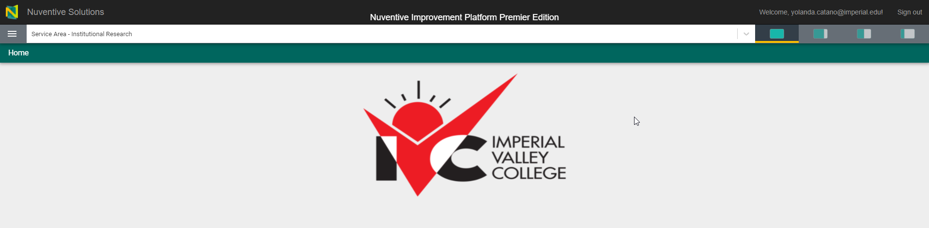

Prioritization & Funding
Program reviews will serve as a basis for annual prioritization, funding and budget planning. Each program/unit will submit the completed program reviews to the appropriate entity as identified in Table 1 to be incorporated into the college’s annual budget process.

The Offices of Institutional Effectiveness and Research shall maintain copies of all program review reports as a permanent archive and will provide data as needed for all program review reports.

The Prioritization Process:

Each discipline/unit completes a program review for the academic year as assigned. For each resource request (budget enhancement) in the program review, a particular resource plan is identified in eight categories:
- Advertisement -- Costs associated with public relations and marketing through different media outlets (print ads, radio or TV broadcasts, online or direct mail).
- Staffing -- Costs associated with salaries and benefits of persons employed by the District to perform duties in an assigned position.
- Facilities -- Costs associated with maintenance and repairs to buildings and other types of facilities (fixing broken floor tiles or replacing old carpet, replacing a sink in a classroom lab, etc.).
- Technology -- Costs associated with telecommunications, data processing and data management systems or services (i.e. telephones, computer networks, internet, fiber optics, etc.)
- Professional Development and Travel -- Costs associated with necessary expenses for District representatives to improve or learn new techniques (i.e. fees for workshops, webinars, classes, etc.). Costs associated with per diem or actual necessary expenses for District representatives to attend meetings or conferences (i.e. registration fees, transportation, meals and lodging.
- Supplies and Equipment -- Costs associated with items that have a useful life of less than one year or are easily expendable, broken, damaged, or lost in normal use (i.e. office supplies, food and food service supplies, medical supplies, etc.). Costs associated with assets having a useful life of more than one year other than land and buildings (i.e. computers, software, furniture, etc.).
- Capital Expenditure -- Costs associated with the acquisition of capital assets or additions to capital assets totaling $5,000 or more (sites and site improvements, buildings, fixtures, equipment, vehicles, etc.).
- Miscellaneous -- Operating costs not identifiable within any other category listed.

Note: Definitions provided by Director of Fiscal Services and Administrative Services area.

Institutional Level:

The review process for all budget enhancement requests will be directed by the Program Review Committee and Institutional Effectiveness and Development Committee.

Budget Enhancement Process and Timeline (Appendix A):

Process | Body of Representatives | Due Dates
Program Level Development and Review | - Program Chairs, Coordinators, Directors submit program review with rated/ranked budget enhancements.  - *FT faculty position requests routed in parallel process to Instructional Council. | - November 13, 2021
Dean Level Review | - Deans review for clarity and appropriateness. | - December 15, 2021
Vice President Level Review | - VPs review for clarity and appropriateness. | - January 15, 2021
IE/IR/Dean/Director Prep | - IE/IR pulls reports from Nuventive and prepares information for college-wide review.  - Deans and Directors review and rate/rank all items for their divisions. | - February 4, 2022
Expanded Joint Deans’ Council Review | - Highest priority budget enhancements college-wide organized with recommended funding sources. | - March 1, 2021
Integrated College Council | - ICC reviews and discusses recommendations of all budget enhancement from the campus. | - Begin March 11, 2022  - Ends May 13, 2022
President’s Cabinet Level Review | - PC receives recommendations from ICC on May 13, 2022.  - PC reviews all requests, focusing mostly on highest priority items. Approved items will best align with the strategic plan and institutional goals. | - Overall budget enhancement allocation sent no later than June BOT for tentative budget.

*Note: All Faculty requests are prioritized separately by the Curriculum Committee and are submitted to the Staffing Committee for inclusion in the institutional prioritization process.

Each of these committees is charged with the responsibility of developing prioritized lists of budget enhancement requests based on the needs of the program reviews submitted in that academic year.
The PRC is to establish guidelines, criteria and/or rubrics for their committee’s prioritization process. Each standing committee will follow the recommended process established by the PRC and discuss the prioritization process. At the end of the manual, you will find the budget enhancement evaluation tool with instructions on the process to evaluate budget enhancement requests.

Data Definitions

Headcount
Student headcount is an unduplicated count of students who are active in a credit class on census day. It is the number of individual students taking classes. Students may enroll in one more courses in a term, but each student is counted only once for the term.

Enrollment
Student enrollment is a duplicated count of students. Students may be enrolled in more than one course. Each enrollment for the day on which active enrollment is counted for computing FTES, the basis for State funding. Census for term‐ length classes is Monday of the 3rd week of classes.

Census Enrollment
Enrollment on census day.

Full‐Time Equivalent Student (FTES)
FTES is a standard statewide measure of student enrollment at an academic department, or an institution. FTES is a key performance indicator, productivity measure, and funding rate. FTES represents neither student headcount nor student enrollment, but it is a conceptual measure of student enrollment. The formula to calculate FTES is expressed by the equation below:

Full‐Time Equivalent Faculty (FTEF)

FTES = (Census enrollment X Weekly student contact hours X Term Length Multiplier) / 525 where TLM = 16.5

Example: FTES for a 3 unit class with 30 students enrolled at census FTES = (30 x 3.38 hours/week x 16.5 weeks/semester) /
525 = 3.19

In a FTEF, a faculty member’s actual workload is standardized against the teaching load. Thus, FTEF does not represent an actual number of faculty members; it is a conceptual measure workload at an academic department, or an institution. The formula to calculate FTEF is expressed by the equation below:

FTEF = WFCH / Contract teaching load of the discipline where
WFCH = standard course hours Example: 3/15 = 0.20
Regular FTEF ‐ FTEF in sections taught by regular, full‐time faculty
Adjunct FTEF ‐ FTEF in sections taught by adjunct faculty
Hourly FTEF ‐ FTEF in sections taught as an overload by regular faculty

Weekly Student Contact Hours (WSCH) & Instructional Efficiency
WSCH is acronym for weekly student contact hours. It presents a total number of hours faculty contacted students weekly in an academic department or an institution.
WSCH = census enrollment x class hours per week
WSCH is a proxy for revenue generated by the class. FTEF is a proxy for instructional cost. The ratio, WSCH per FTEF could be interpreted in terms of cost‐efficiency or instructional quality. District has established 510 as the target WSCH/FTEF standard.

Average Class Size A measure of the enrollment per section

Mode of Instructional Delivery
Classroom ‐ Traditional classes offered 'on ground' in a classroom
Hybrid ‐ Classes that are offered both online and in the classroom.
Online ‐ Web‐based classes
Section Count The number of sections offered, including combined classes counted separately
Success Rate The percentage of students who received a passing grade of A, B, C, P at
the end of the semester.
Success rate Passing Grades (A,B,C,P) divided by all grades in a class
(A,B,C,D,F,P,N,W,I)
Retention Rate The percentage of students retained in a class at the end of the semester
All students who earned a letter grade (A,B,C,D,F,N,P,I) divided by all students, including withdrawals (A,B,C,D,F,P,N,I,W)
Persistence Rate Number of students with at least one course in next term divided by
Number of students with at least one course in The first term
Degrees Associate of Arts, Associate of Science, and all ADTs or Transfer Degrees
Certificate Awards requiring 18 or more units
Division Academic division that includes one or more disciplines/subjects
Program The program in which an award is earned by a student
Fiscal Year July 1 ‐ June 30
AY (Academic Year) Summer ‐ Fall ‐ Winter ‐ Spring
Restricted and Categorical Funds
Funds restricted to a particular categorical program or grant
Unrestricted Funds Funds comprising the general fund of the college
Actual Expenditures Expenses according to the year‐end closing as reported in the
final Budget
Budget Final Budget adopted by the Board

Appendix A
Budget Enhancement Process and Timeline
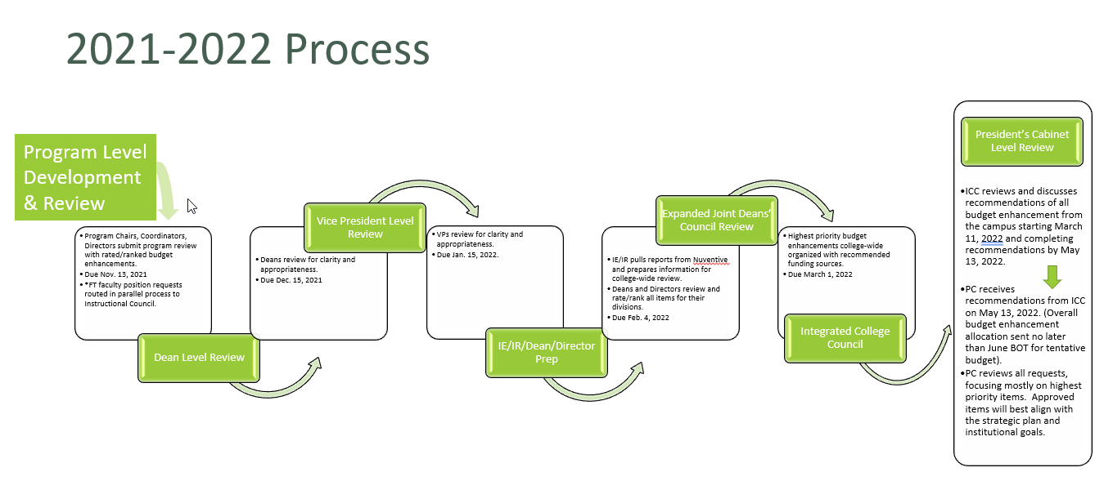

Appendix B
Budget Enhancement Tool
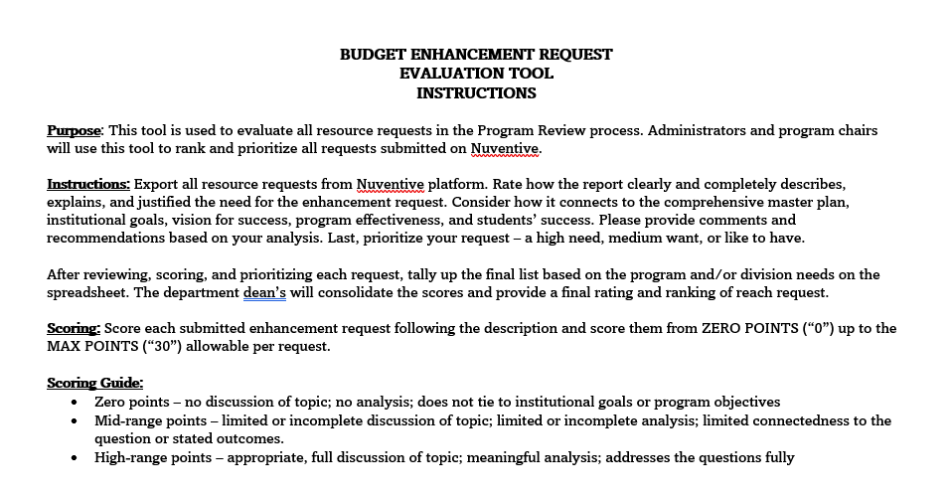

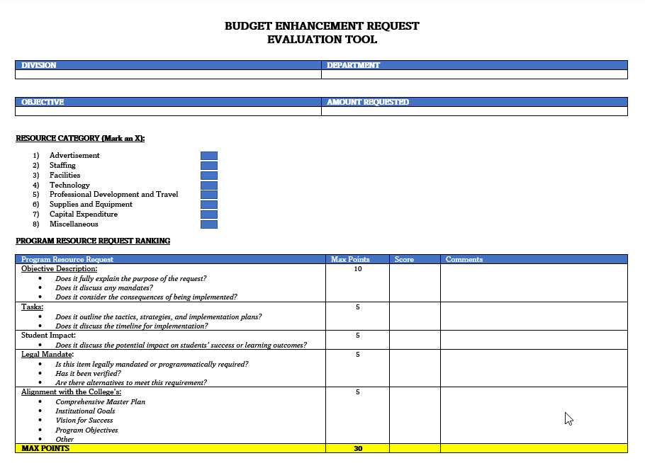
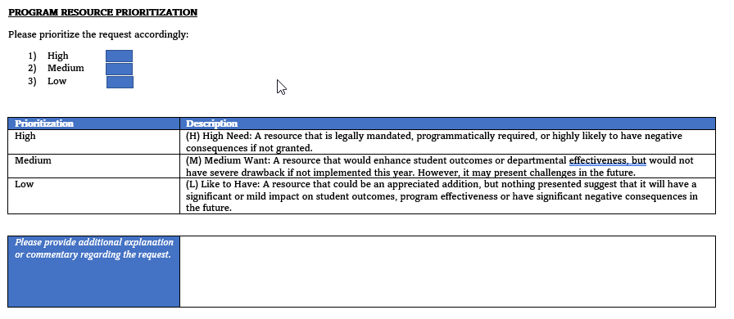

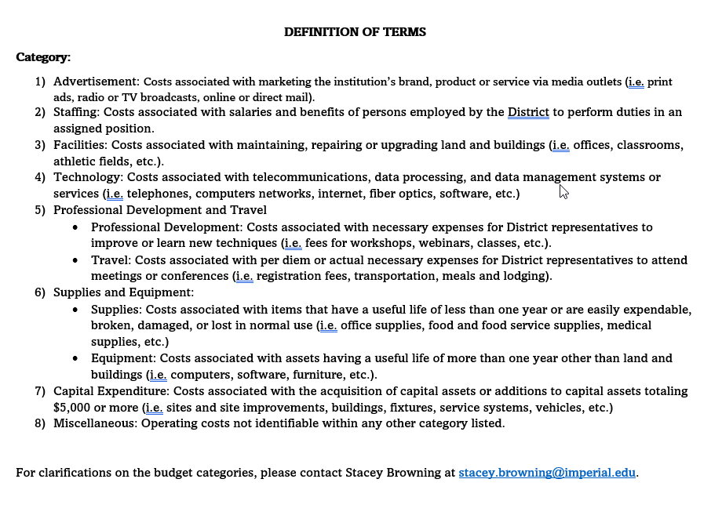

Appendix C
SMART Goals
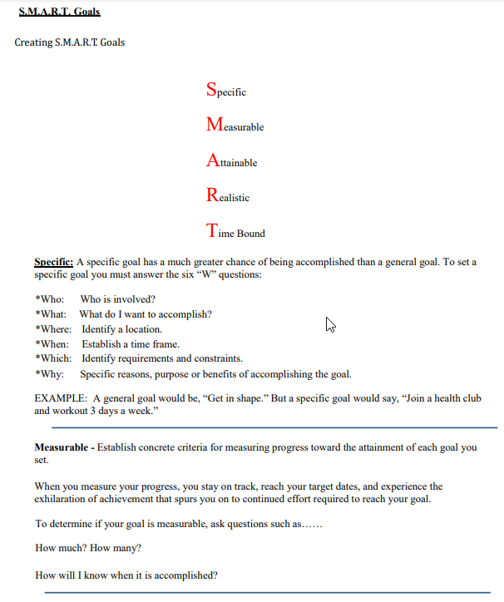

Appendix D
Comprehensive Master Plan - Institutional Goals
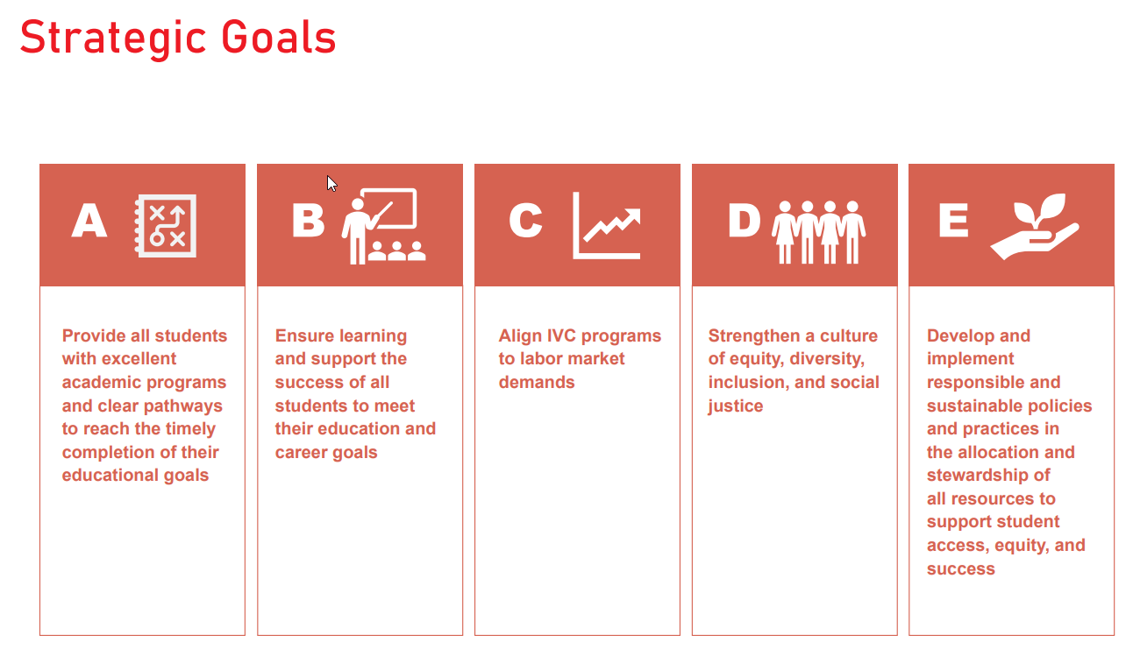
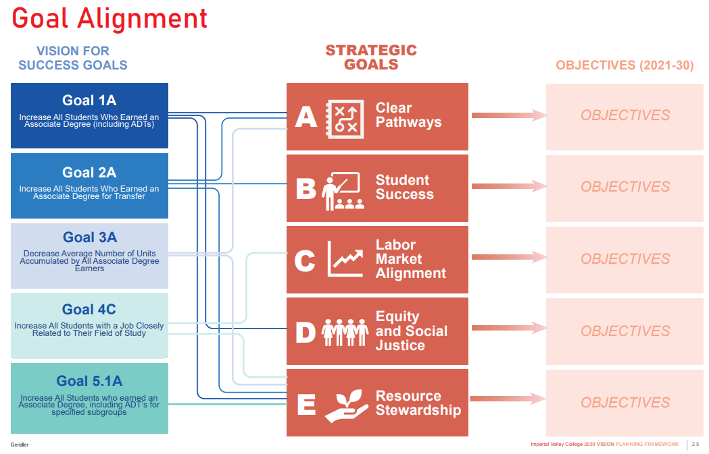

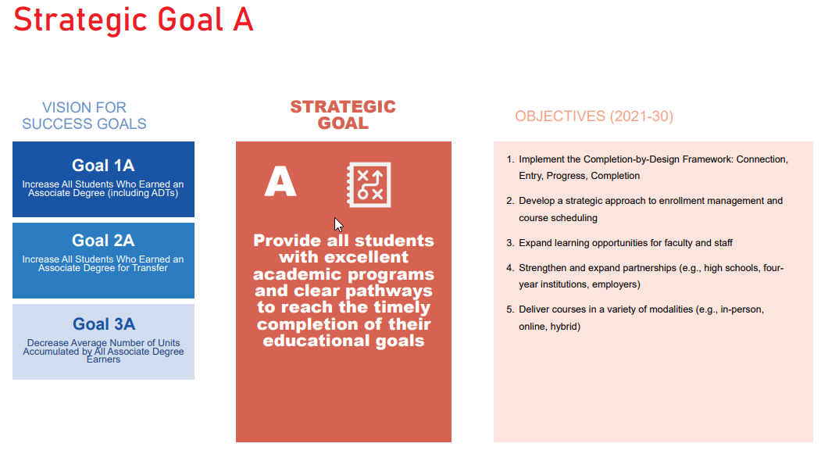

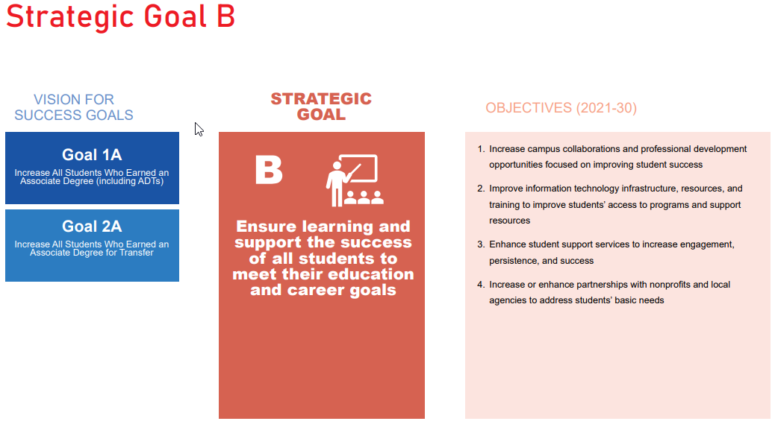
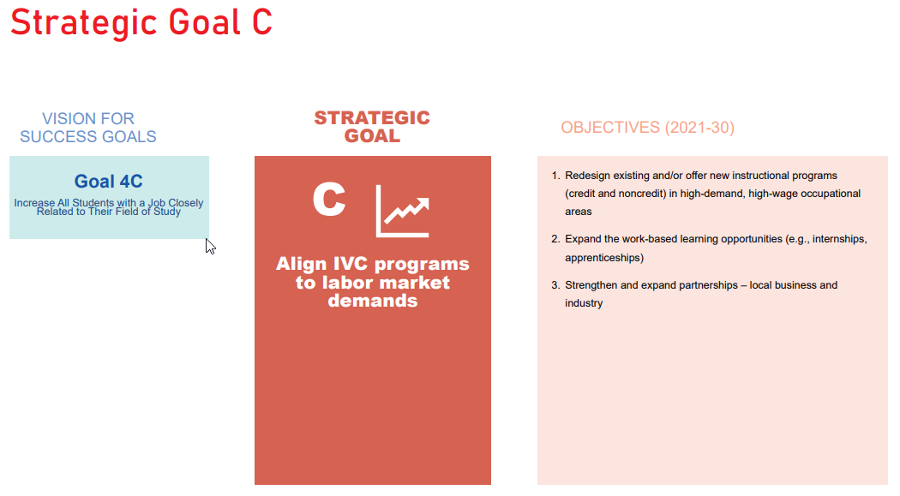
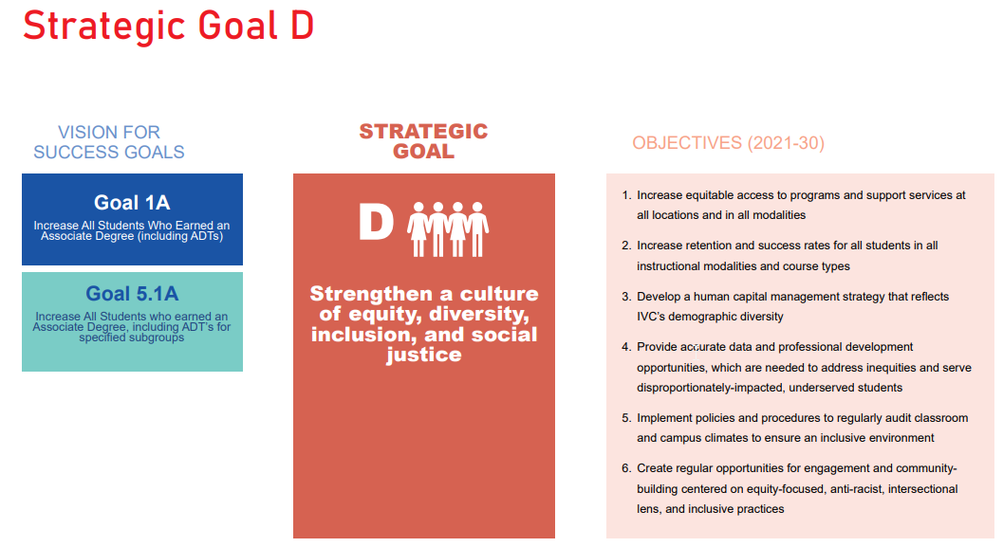
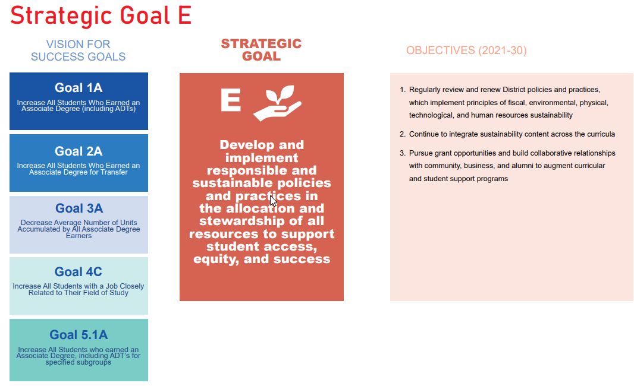

Appendix D
ACCJC Rubric for Evaluating Institutional Effectiveness - Part I: Program Review
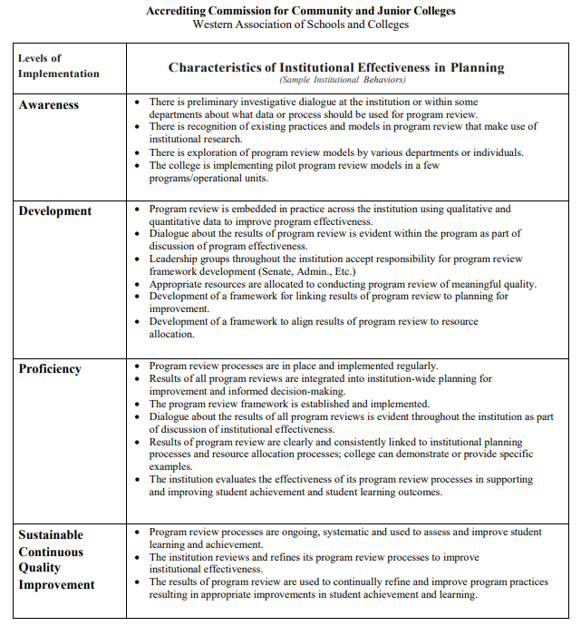

ACCJC Rubric for Evaluating Institutional Effectiveness - Part II: Program Review
