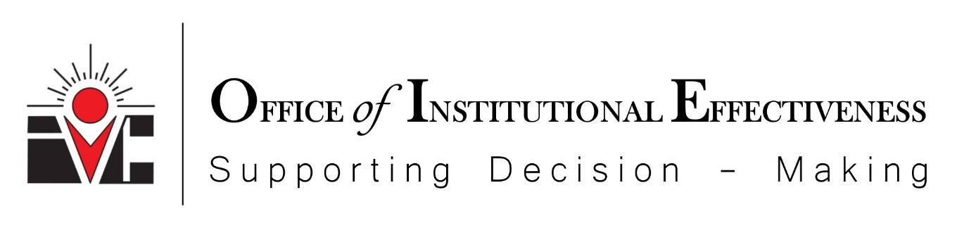

IMPERIAL VALLEY COLLEGE
NUVENTIVE GUIDE
Last updated: August 26, 2021

Access to Nuventive Platform in IVC Portal
Program review updates are entered in the planning module of Nuventive.
Access:
- Log in to Nuventive: https://sso.imperial.edu/_layouts/PG/login.aspx?ReturnUrl=%2Fsso%2Fdefault.aspx. Use your IVC credentials as demonstrated below to access the portal.
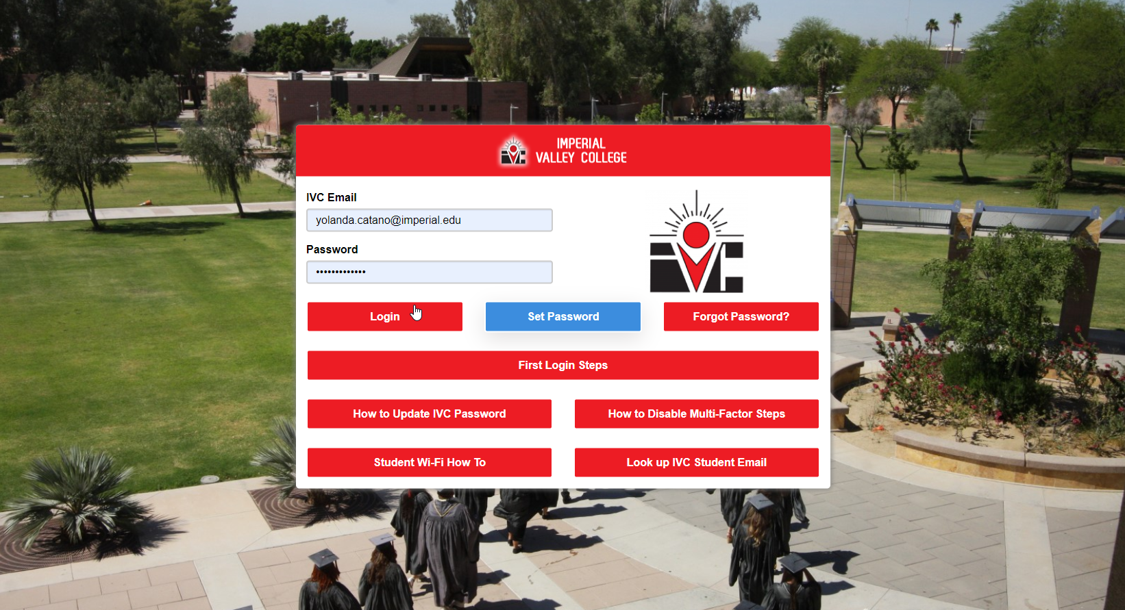
- Single Sign-On Portal – Click on the Nuventive tab to access the platform.
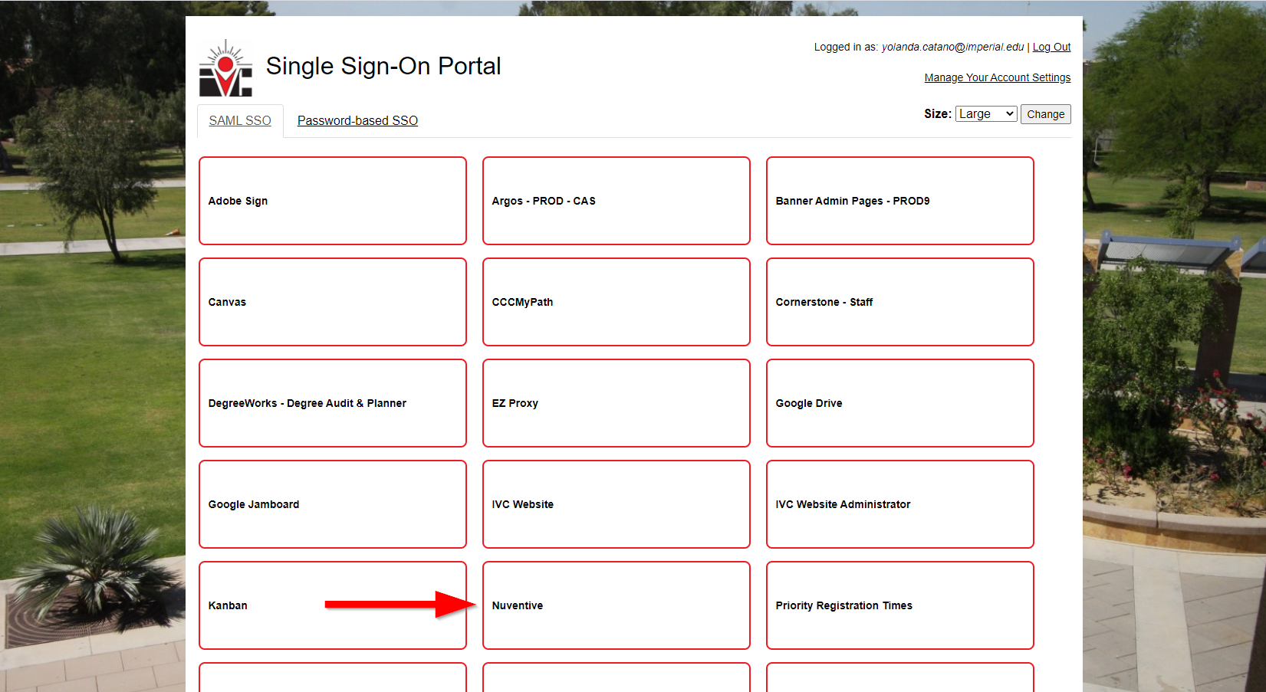

- View of the Nuventive Platform.
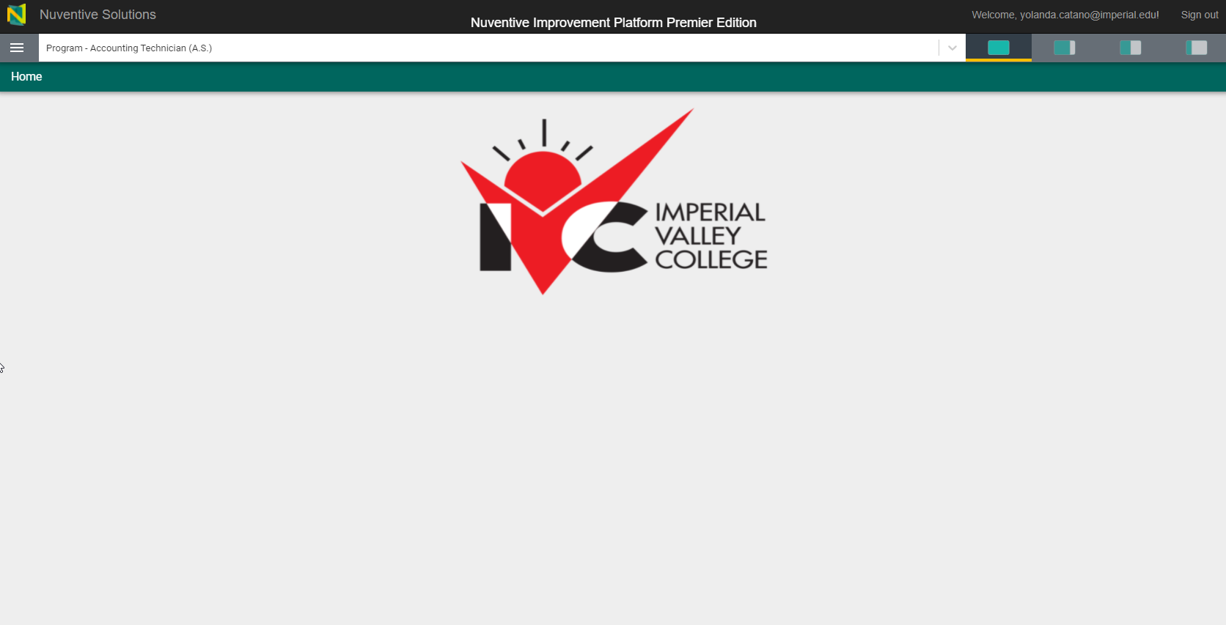

- Click on the menu (3 bars) on the top left to access Program Review Information.
  - Home
  - Program Information
  - Program Learning Outcomes Assessment
  - Program Review
  - Document Library
Please note: Not all menu options will be visible to all users.
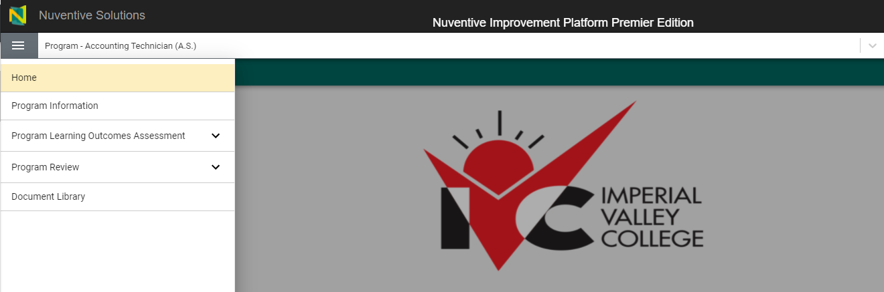

- Click on Program Information to view information about this unit. This information typically won’t change from year-to-year and will appear on your program review report.
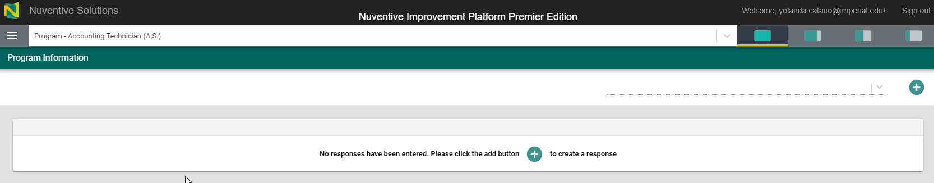

- Click on the green plus sign to access the program information page to enter your information. (If information is provided to Nuventive reps then I will update this information.)
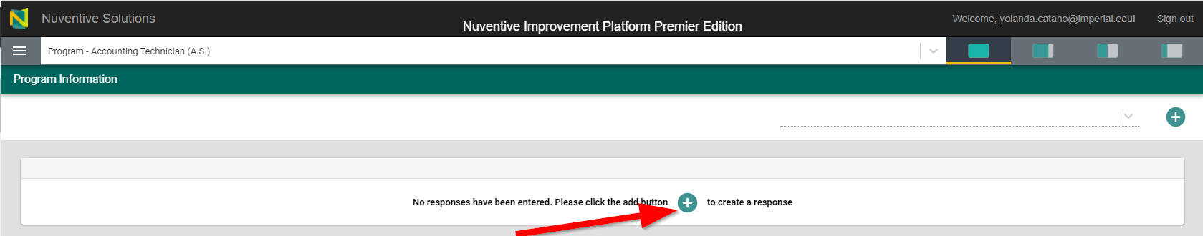
- Begin entering your program information based on the academic year 2021-2022. The program information entails the following:
  - Mission Statement
  - Division
  - Department
  - Assessment Lead (If you are the person submitting final assessment results for the department or program. This is usually the administrator or program chair.)
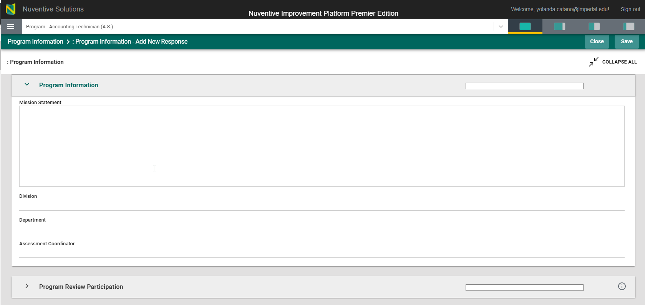

Program Learning Outcomes Assessment
To access the Program Learning Outcomes Assessment tab, click the three lines on the top left and this pop up will appear:
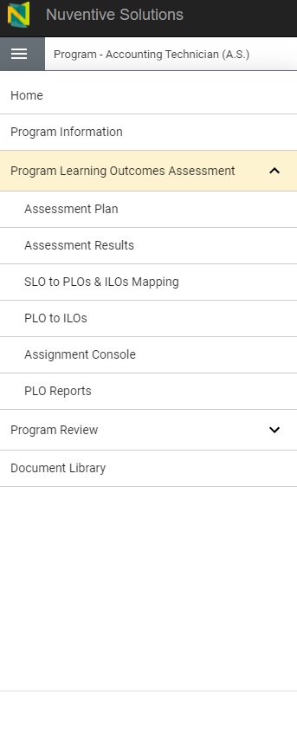
- Click on the assessment plan to view your Program Learning Outcomes. Each PLO indicates if it’s active or not.
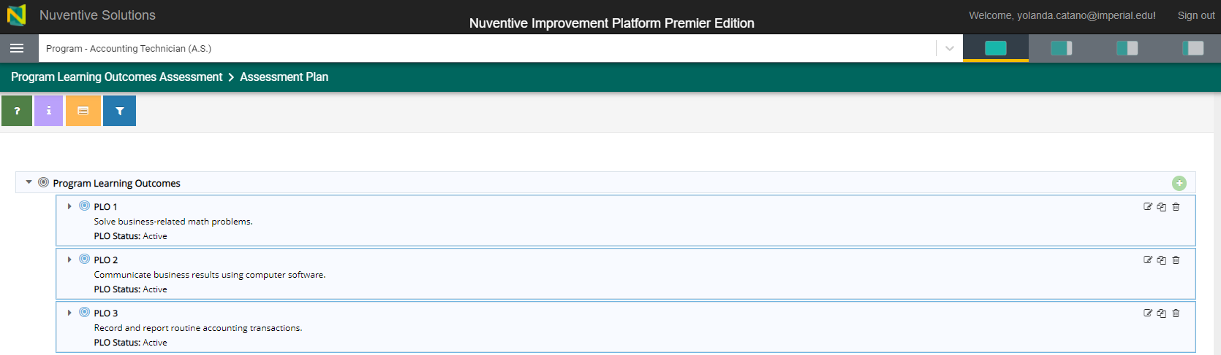

- Click on the side arrow to open up the assessment methods portion.
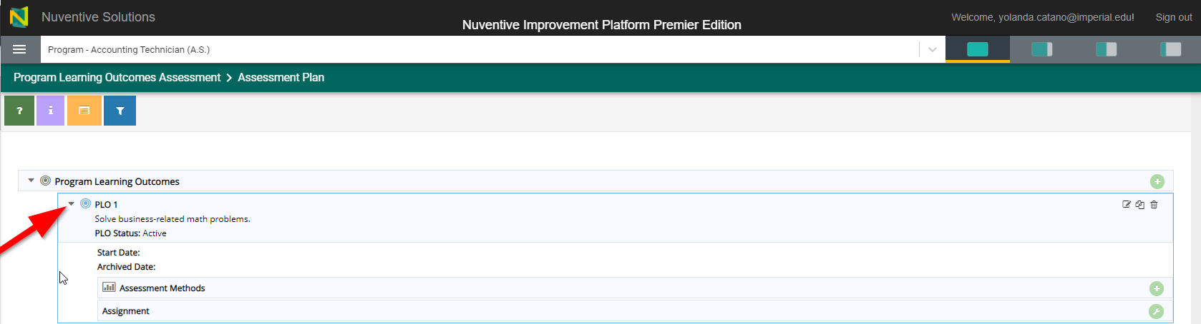
- Click the assessment green plus sign on the right to enter assessment method information.
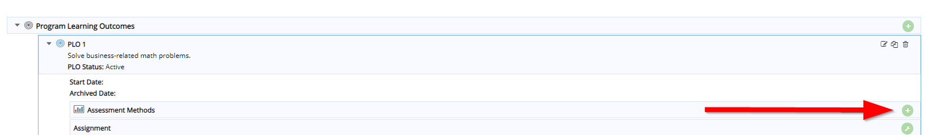
- The assessment method screen will appear to enter additional information. Please make sure to save your work before moving on to the next assignment.
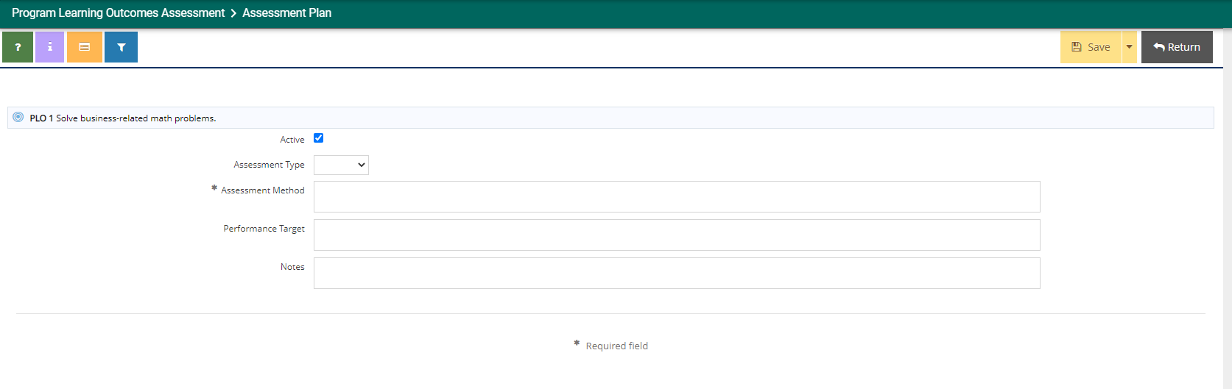

- When you click on the SLOs to PLOs & ILOs Mapping side bar, the following items will appear:
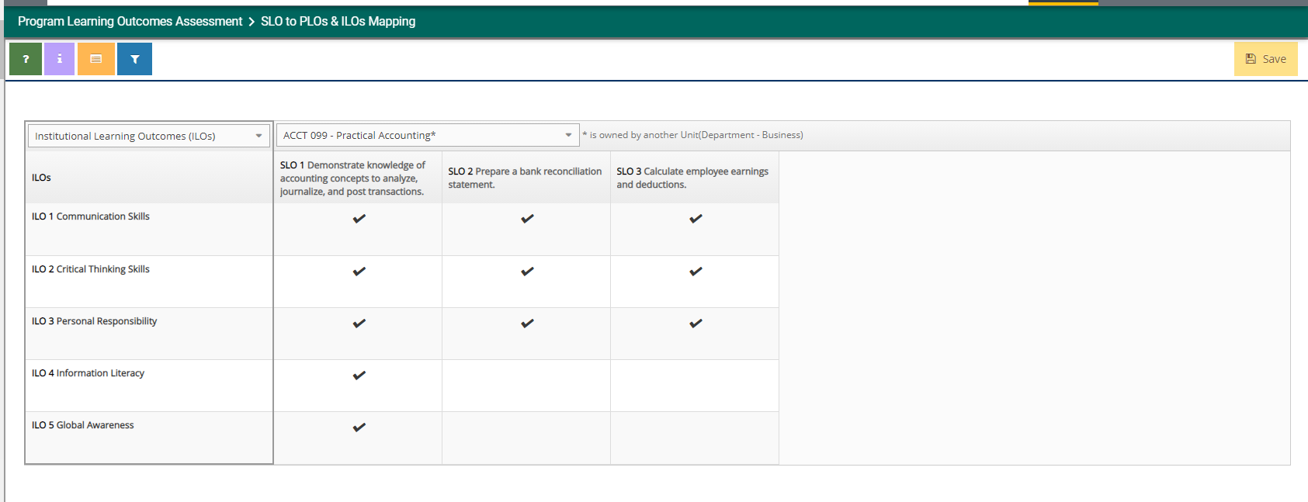
You will align your ILOs to your SLOs here by clicking the cell at the intersection and a checkmark will appear.
- Course SLOs and PLOs will be managed through assignments. An assignment link will be emailed to you. Clicking on it will provide you with an overview on the status of your assignments that require your attention.
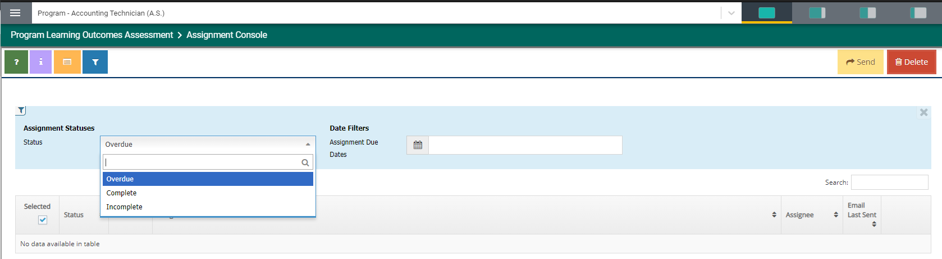
- Once mapping has occurred, Nuventive has the capacity to print program reports and they are accessed under the Program Learning Outcomes Assessment tab.
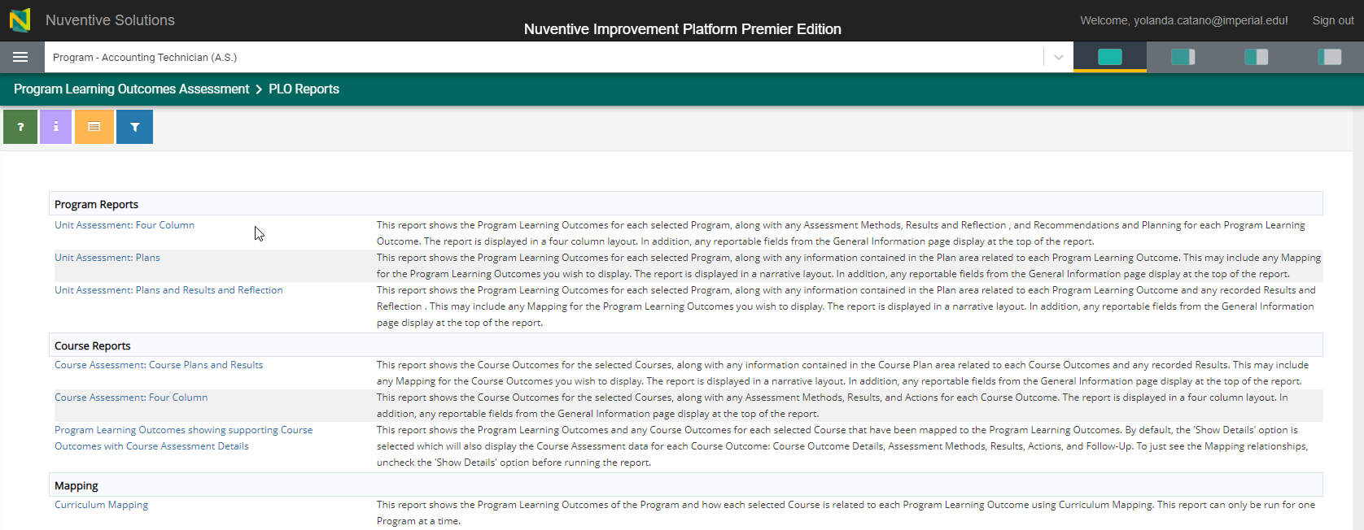

- When you click on any of the report options, it will ask you additional questions to create the report and in what format.
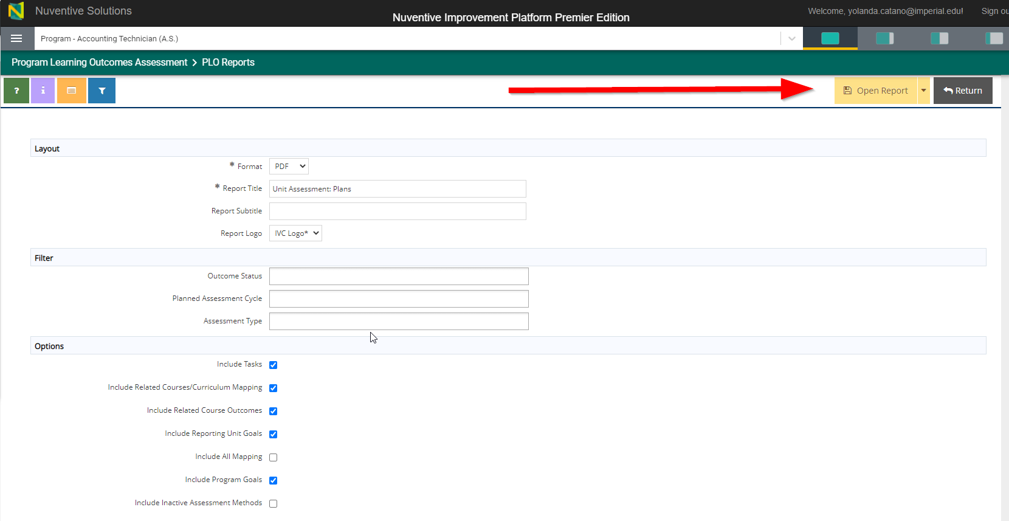

Budget Enhancement Requests and Institutional Mapping and Planning
- Click on Program Review on the left tab.
- Open Objectives, Tasks, and Budget Enhancements.
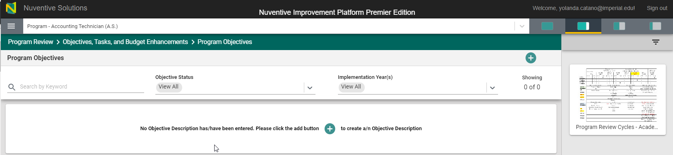
- Click on green tab to open objective description.

- The next screen will appear to ask you to enter the objective description information.
  - Objective Name
  - Objective Description
  - Objective Status
  - Implementation Year(s)
  - How will the objective be measured?
  - Explain how you linked your assessments (SLO/SAO/PLO/ILO) to this objective
  - Explain how you linked your Vision for Success Goals to this objective.
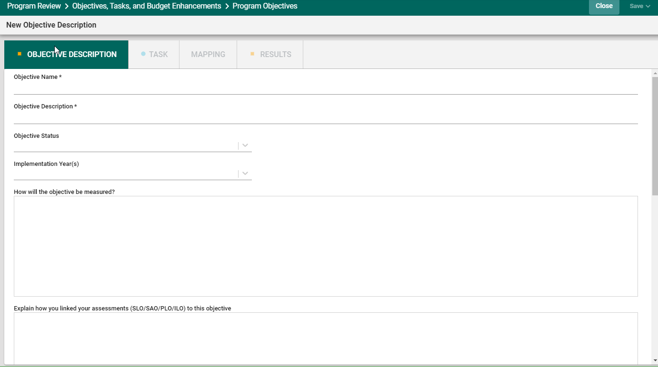

- Once you have created an objective, click on the task tab.
- The task drop down will take you to the budget enhancement request based off of the associated objective. Please note: If your objective does not require a budget request, only fill out the task status, timeline, and overall task for completing the objective.
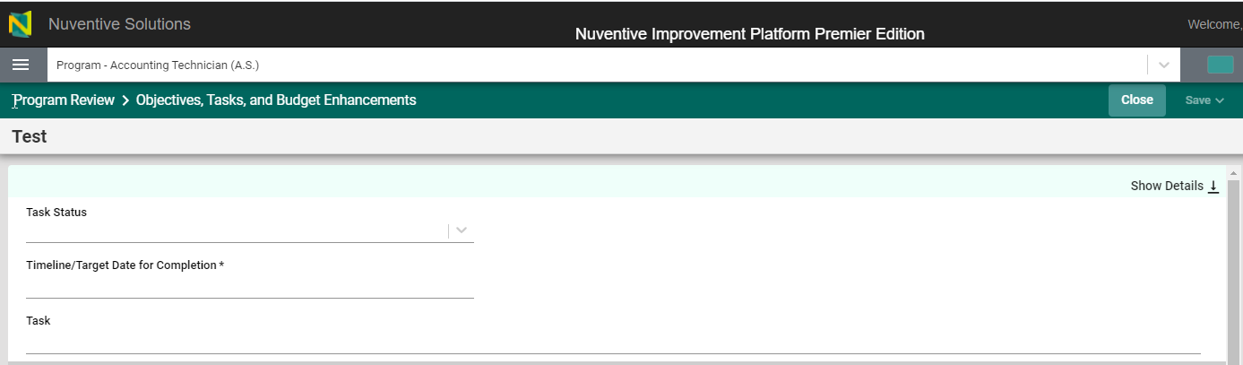

- Budget Enhancement Requests (Only complete the following fields if requestion a budget enhancement)
  - Category
  - Expense Type
  - Funding Type
    - If categorical, specify.
  - Budget Request Among
  - Supporting Documents
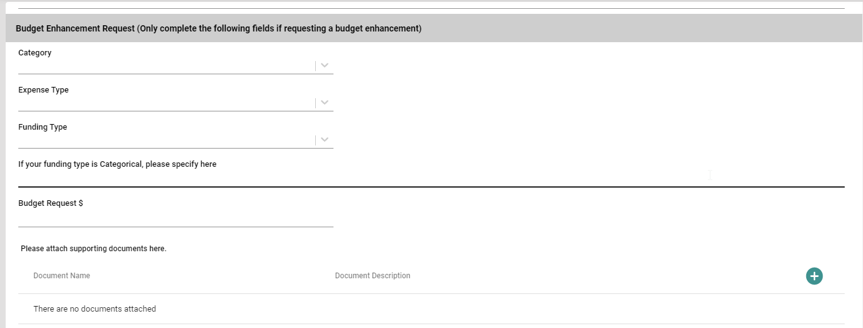

- Budget Request Status.
  - Status of Budget Request
  - Additional Information
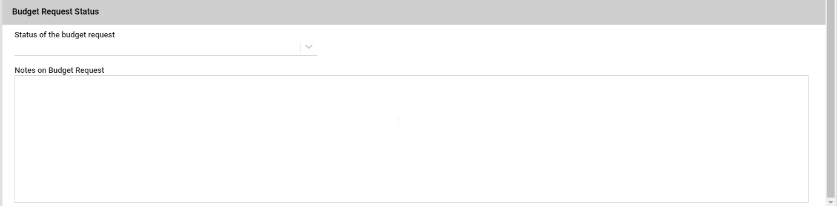

- Comprehensive Program Review
  - Click on the cycle year to access your comprehensive program review information. More importantly, please note the side panels on the right to access additional documents that can help you enter information.
    - Program Review Cycles – Academic Services and Service Areas (Administrative and Student Services).
    - Tableau Dashboard – Academic Services only
    - Live Enrollment Data – (Metabase)
  - Click on the thumbnail and it will open a split screen.
    - The icons at the top can be used to manage the size of the data view.

Example #1
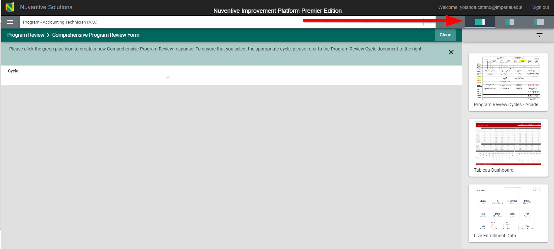

Example #2
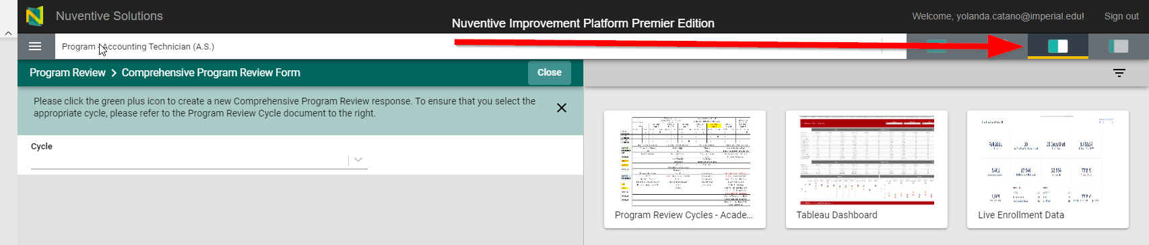
Example #3
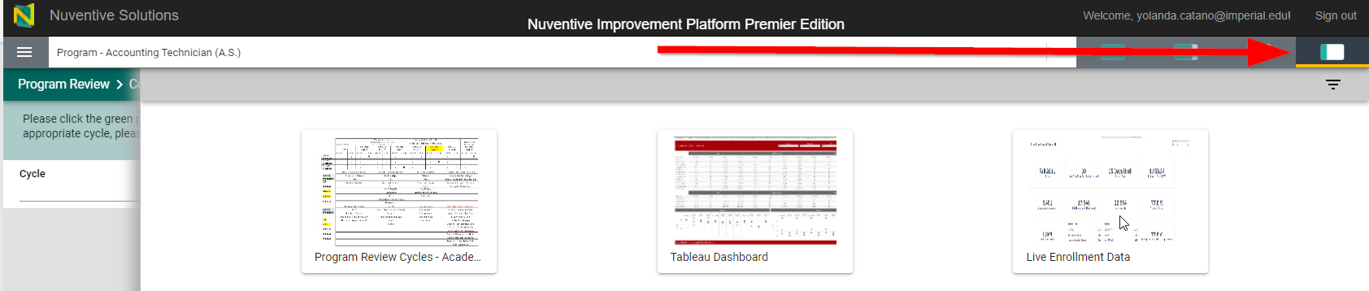
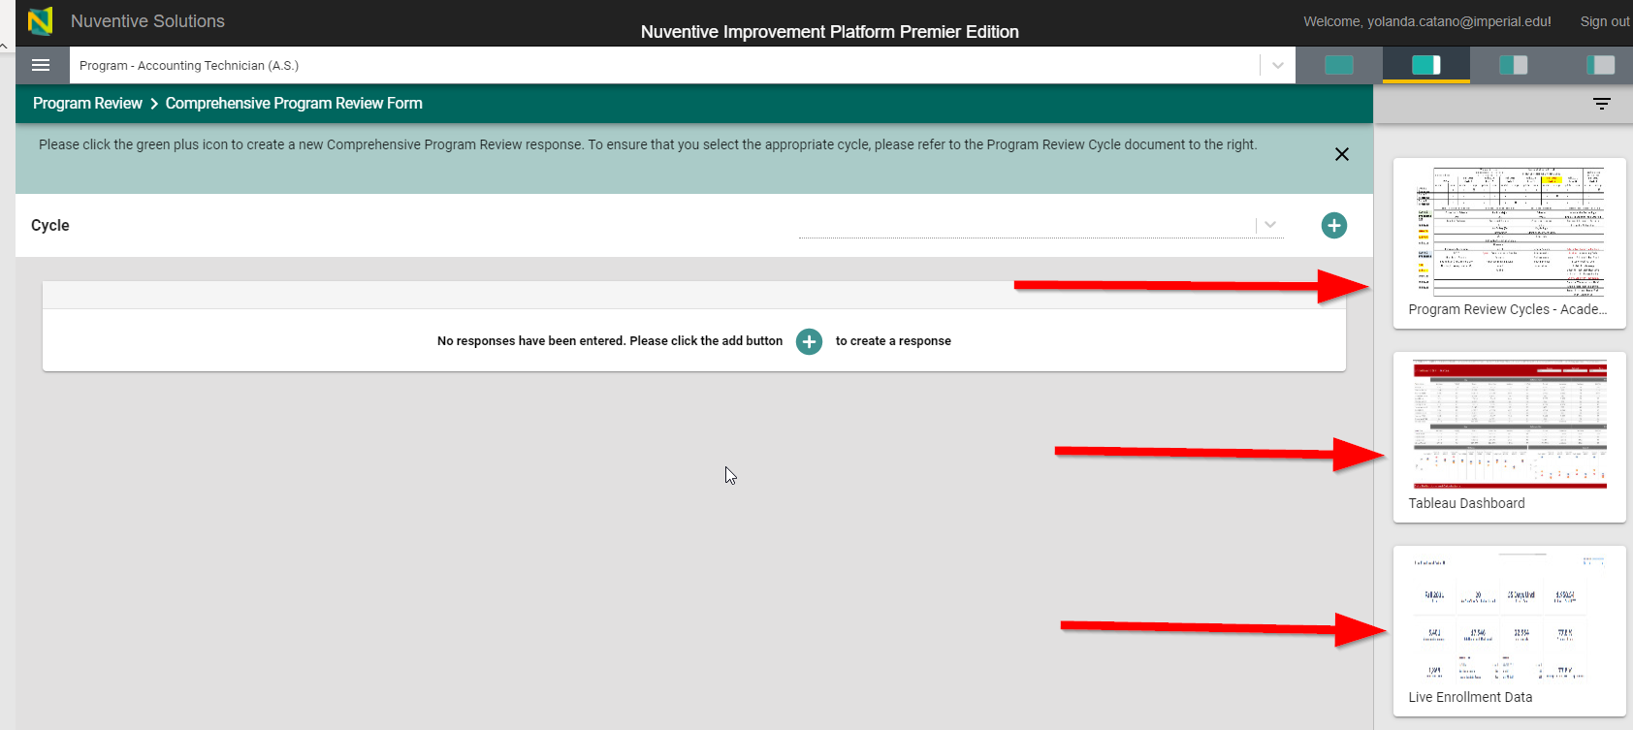

- The Mapping to Institutional Goals and Vision for Success Goals screen.
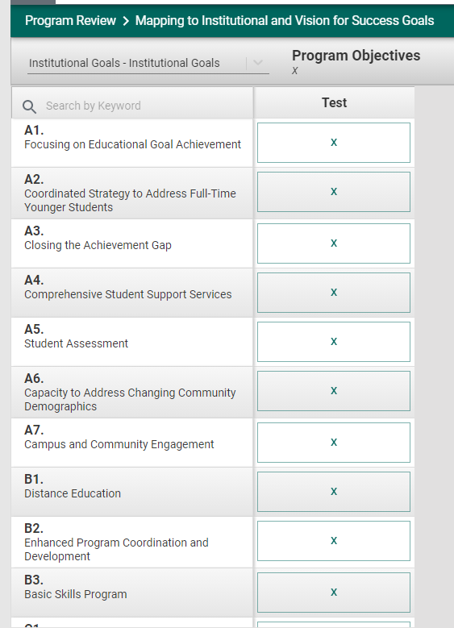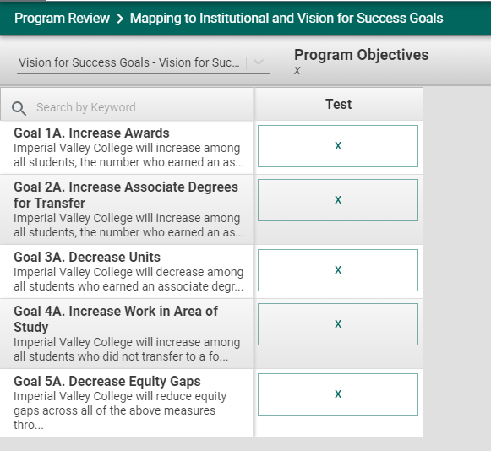

Program Review Report
You can download your Program Review Reports in various formats.
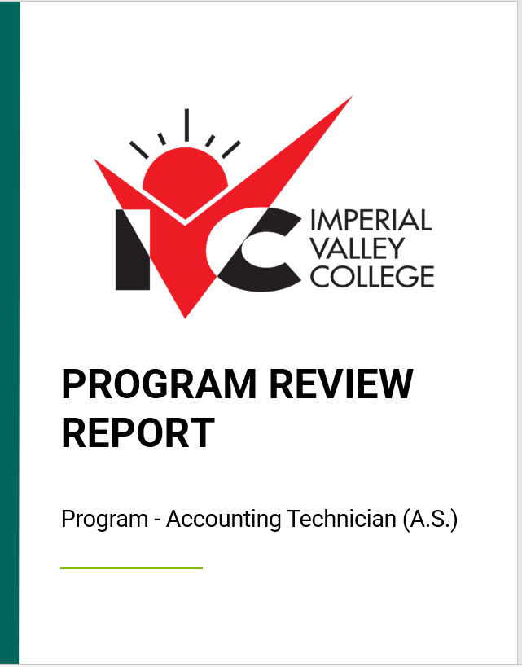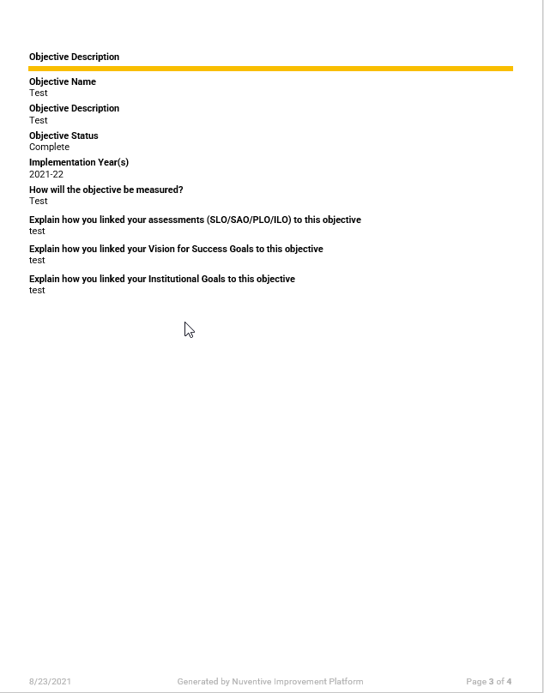

Assistance with Program Review
Please Contact:
IVC Program Review
Department | Representatives | Email | Ext.
Office of Institutional Effectiveness | Yolanda Cataño | Yolanda.catano@imperial.edu | X5710
Office of Institutional Research | Jose Carrillo | Jose.carrillo@imperial.edu | X6487
Office of Institutional Research | Oliver Zambrano | Oliver.zambrano@imperial.edu | X6130
Outcomes and Assessment | Kevin Howell | Kevin.howell@imperial.edu | X5712
Outcomes and Assessment | Dixie Krimm | Dixie.krimm@imperial.edu | X6344
IT | Jeff Enz | Jeff.enz@imperial.edu
IT | Jeff Cantwell | Jeff.cantwell@imperial.edu | X6388
IT | Omar Ramos | Omar.ramos@imperial.edu | X6500
Administrative Services | Cesar Vega | Cesar.vega@imperial.edu | TBD
Budget and Enhancement Process | Stacey Browning | Stacey.browning@imperial.edu | X6234
Oversight:
President’s Office:
- Interim Superintendent/President, Dr. Lennor Johnson
President’s Cabinet:
- Vice-President of Academic Services, Dr. Christina Tafoya
- Interim Vice-President of Student Services, Dr. Henry Covarrubias
- Vice-President of Administrative Services, Cesar Vega
- Chief of Technology – Jeff Enz
- Chief of Human Resources – Clint Dougherty

